SELENIUM CC1

BHUVANESHWARI R

727721EUCS021

1)Adding a product to cart and checkout:

Coding:

Newcc1.java:

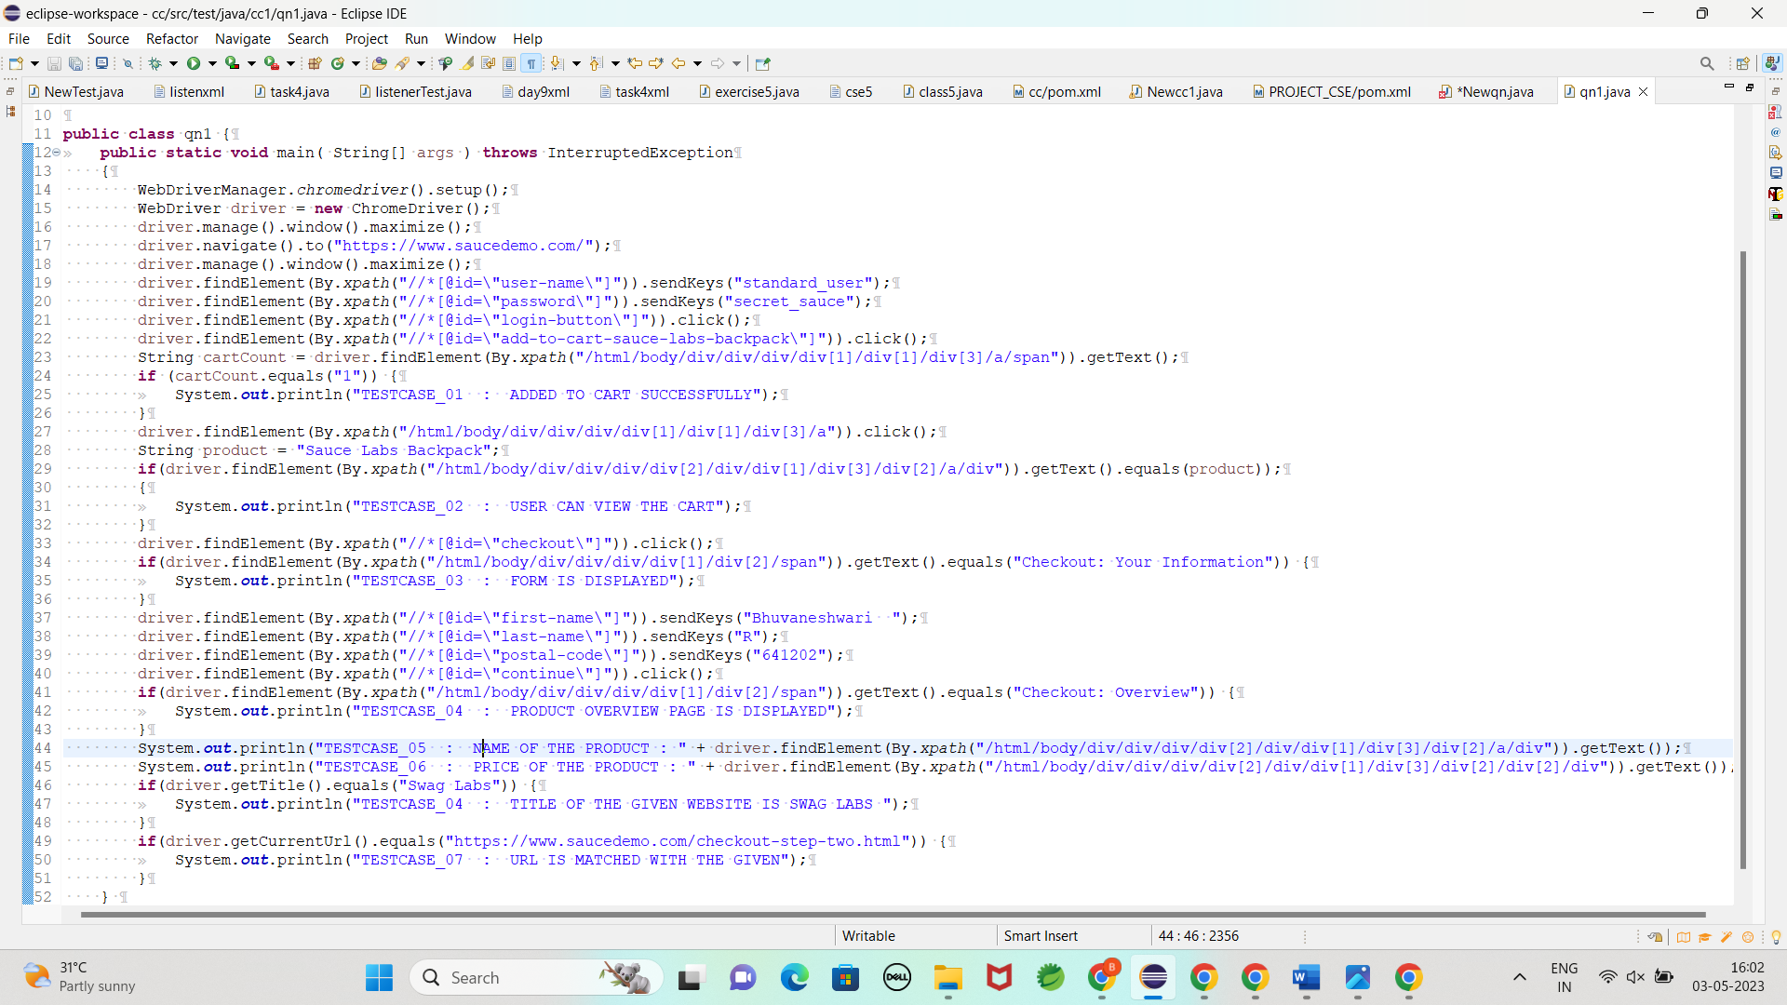

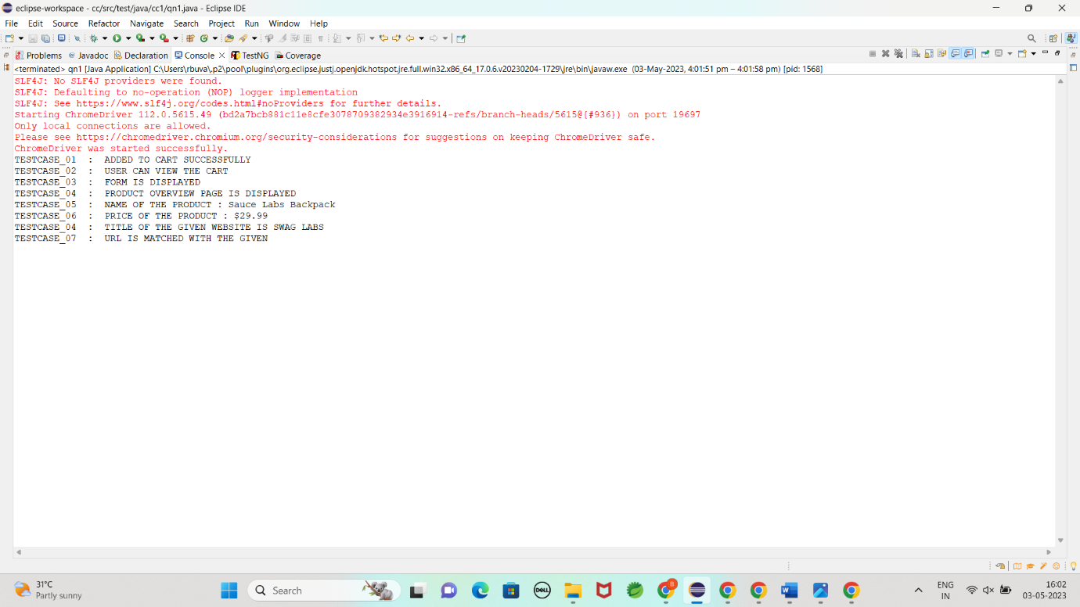

OUTPUT:

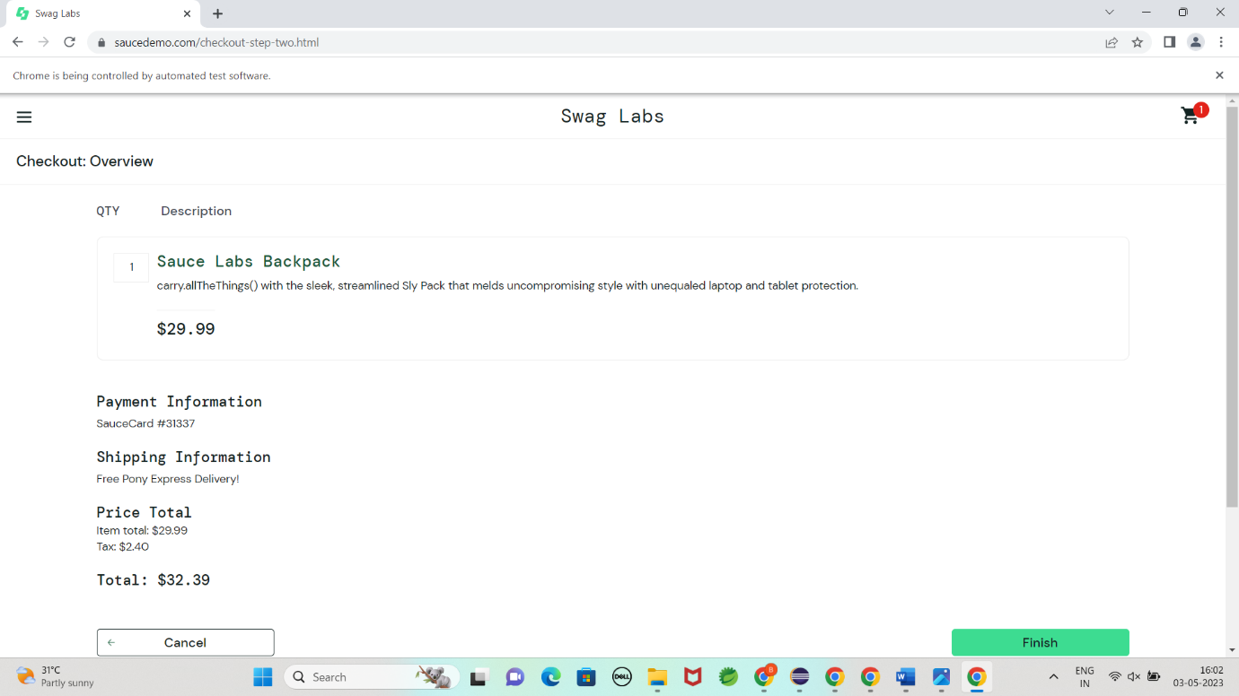

2)Filter Option:

Coding:

Newqn.java:

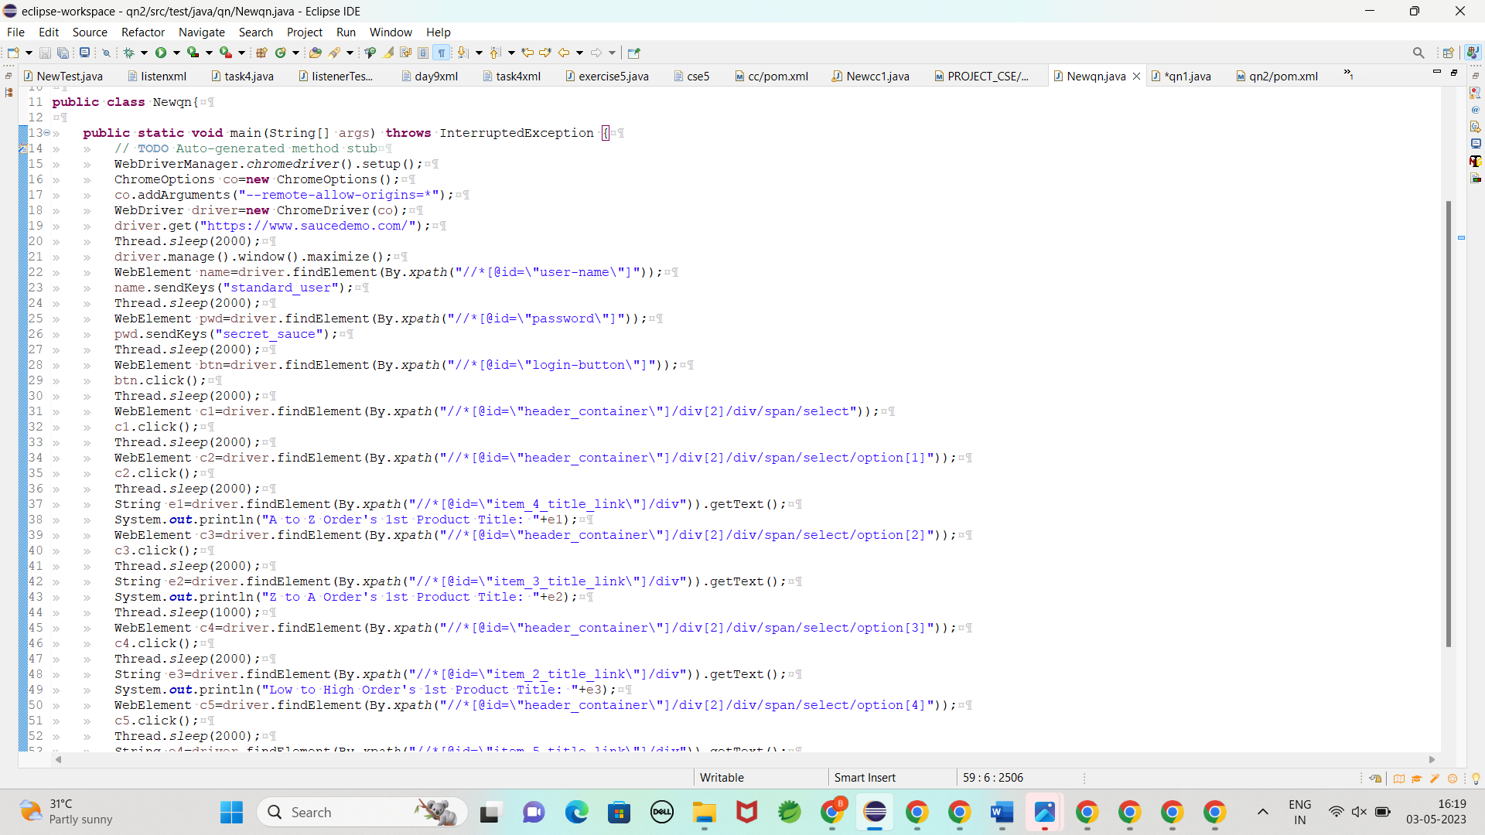

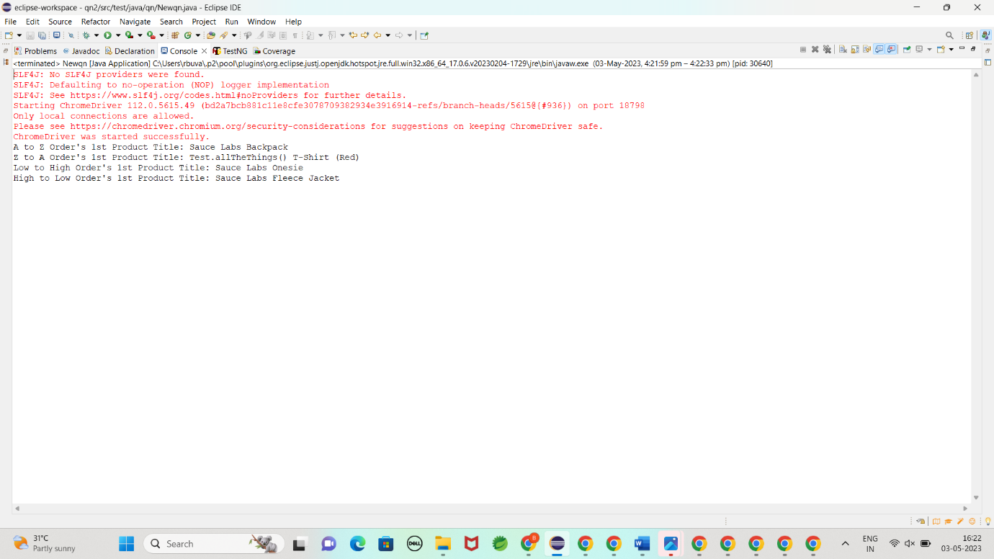

Output:

